# Final Year B. Tech., Sem VII 2024-25

High Performance Computing Lab

**Practical No. 9**

## Implement Matrix-Vector Multiplication using MPI. Use different number of processes and analyze the performance.

CODE :

#include <mpi.h>

#include <stdio.h>

#include <stdlib.h>

int main(int argc, char** argv) {

MPI_Init(&argc, &argv);

int world_size, world_rank;

MPI_Comm_size(MPI_COMM_WORLD, &world_size);

MPI_Comm_rank(MPI_COMM_WORLD, &world_rank);

int m = 5;

int n = 5;

int *A = NULL;

int *x = (int*)malloc(n * sizeof(int));

int *local_A;

int local_m = m / world_size;

if (world_rank == 0) {

A = (int*)malloc(m * n * sizeof(int));

for (int i = 0; i < m; i++) {

for (int j = 0; j < n; j++) {

A[i * n + j] = i + j;

}

}

for (int i = 0; i < n; i++) {

x[i] = i + 1;

}

}

local_A = (int*)malloc(local_m * n * sizeof(int));

double start_time = MPI_Wtime();

MPI_Scatter(A, local_m * n, MPI_INT, local_A, local_m * n, MPI_INT, 0, MPI_COMM_WORLD);

MPI_Bcast(x, n, MPI_INT, 0, MPI_COMM_WORLD);

int* local_y = (int*)malloc(local_m * sizeof(int));

for (int i = 0; i < local_m; i++) {

local_y[i] = 0;

for (int j = 0; j < n; j++) {

local_y[i] += local_A[i * n + j] * x[j];

}

}

int* y = NULL;

if (world_rank == 0) {

y = (int*)malloc(m * sizeof(int));

}

MPI_Gather(local_y, local_m, MPI_INT, y, local_m, MPI_INT, 0, MPI_COMM_WORLD);

double end_time = MPI_Wtime();

if (world_rank == 0) {

printf("Resultant vector y = A * x:\n");

for (int i = 0; i < m; i++) {

printf("%d ", y[i]);

}

printf("\n");

printf("Total execution time with %d processes: %f seconds\n", world_size, end_time - start_time);

}

free(local_A);

free(local_y);

free(x);

if (world_rank == 0) {

free(A);

free(y);

}

MPI_Finalize();

return 0;

}

Passing processes through cmd

for 4 and 6 processes clear diffrence is there in execution time

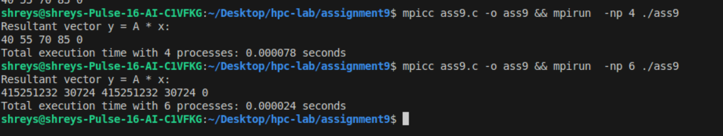

## Implement Matrix-Matrix Multiplication using MPI. Use different number of processes and analyze the performance.

CODE :

#include <mpi.h>

#include <stdio.h>

#include <stdlib.h>

#define N 4

void matrixMultiply(int* A_local, int* B, int* C_local, int rows_per_proc, int n) {

for (int i = 0; i < rows_per_proc; i++) {

for (int j = 0; j < n; j++) {

C_local[i * n + j] = 0;

for (int k = 0; k < n; k++) {

C_local[i * n + j] += A_local[i * n + k] * B[k * n + j];

}

}

}

}

int main(int argc, char** argv) {

int rank, size;

MPI_Init(&argc, &argv);

MPI_Comm_rank(MPI_COMM_WORLD, &rank);

MPI_Comm_size(MPI_COMM_WORLD, &size);

int rows_per_proc = N / size;

int* A = NULL;

int* B = (int*)malloc(N * N * sizeof(int));

int* C = NULL;

if (rank == 0) {

A = (int*)malloc(N * N * sizeof(int));

C = (int*)malloc(N * N * sizeof(int));

for (int i = 0; i < N; i++) {

for (int j = 0; j < N; j++) {

A[i * N + j] = i + j;

B[i * N + j] = i * j;

}

}

}

int* A_local = (int*)malloc(rows_per_proc * N * sizeof(int));

int* C_local = (int*)malloc(rows_per_proc * N * sizeof(int));

double start_time = MPI_Wtime();

MPI_Scatter(A, rows_per_proc * N, MPI_INT, A_local, rows_per_proc * N, MPI_INT, 0, MPI_COMM_WORLD);

MPI_Bcast(B, N * N, MPI_INT, 0, MPI_COMM_WORLD);

matrixMultiply(A_local, B, C_local, rows_per_proc, N);

MPI_Gather(C_local, rows_per_proc * N, MPI_INT, C, rows_per_proc * N, MPI_INT, 0, MPI_COMM_WORLD);

double end_time = MPI_Wtime();

if (rank == 0) {

printf("Resulting Matrix C:\n");

for (int i = 0; i < N; i++) {

for (int j = 0; j < N; j++) {

printf("%d ", C[i * N + j]);

}

printf("\n");

}

printf("Total execution time with %d processes: %f seconds\n", size, end_time - start_time);

}

free(A_local);

free(C_local);

free(B);

if (rank == 0) {

free(A);

free(C);

}

MPI_Finalize();

return 0;

}

Execution with 4 as no. of processes and 4 respectively

